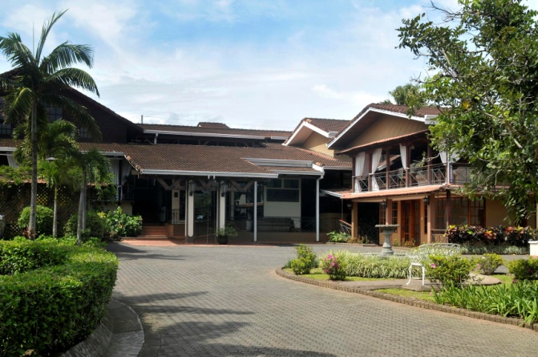

El Rodeo Hotel& Steak House is a four star hacienda style boutique hotel, with a CST (Certification for Sustainable Tourism)  by the Costa Rican Tourism Institute.

We are located only 15 minutes from the SJO International Airport in the heart of the San Antonio de Belen-Santa Ana business - residential district, and only 25 minutes from San Jose Downtown.

Hotel El Rodeo replaces the impersonal atmosphere of hotel chains with the sympathy and warmth of the Costa Ricans, plus exceptional service and great comfort in a relaxed and natural atmosphere.  
  
The hotel has 29 rooms, and offers each guest the following facilities:

* El Rodeo Steak House Restaurant
* Meetings Rooms (available for 12, 50 y/o 400 people)
* Private Parking
* Swimming Pool
* Sauna
* Gym
* Tennis Court
* Tour Desk
* Transfer from SJO Intl. Airport to Hotel (additional charge apply)
* Exchange Rate Service
* Laundry Service
* Games Room
* Business Center

**Rooms Description**

* **Deluxe Room**

22 Deluxe Rooms, equipped with 2 Queen Size Beds, Cable TV, Air Conditioning, Telephone, Radio AM/FM Alarm, Private bathroom, Hair Dryer, Coffee Maker, Safety Box, Iron & Ironing Board.

* **Junior Suite**

4 Junior Suites equipped with 2 Queen Size Beds, Cable TV, Air Conditioning, Telephone, Radio AM/FM Alarm, Private bathroom (tub), Hair Dryer, Coffee Maker, Safety Box, Iron & Ironing Board.

* **Suite**

3 Suites, equipped with 1 King Size Bed, Cable TV, Air Conditioning, Telephone, Radio AM/FM Alarm, Private bathroom w.tub/jacuzzi, Hair Dryer, Coffee Maker, Safety Box, Iron & Ironing Board, Mini Living Room & Jacuzzi.

**RACK RATES 2012/2013**

|  |  |
| --- | --- |
| ROOM | SGL / DBL |
| Deluxe | $ 125 USD |
| Junior Suite | $ 150 USD |
| Suite | $ 175 USD |

* Rates do not include Sales Taxes (13%)
* Rates apply per room per night, single or double occupancy
* Cost per additional person per night is $ 15 per night
* **Maximum 3 persons (adults) allowed per room**
* All rooms are NO SMOKING (penalty applies $150 per stay)

**Payment policy**

**.** Prepayment-deposit and credit card guarantee.

**Cancellations policy**

**.** Cancellations must be in writing at least 48 hours (FITs*) prior to guest's arrival, canceling in less than 48 hours  will be considered "No Show" and is not refundable, except in cases of force majeure (natural disasters, closure of airport).

**.** *Group cancellations at least 30 days prior to group’s arrival.

**.** No refunds if nights booked are not fully used.

Please if you need any other information please contact me, it would be my pleasure to assist you.

Regards,

**Robert Lucien Lichtveld**

**Operations Director**

**Hotel El Rodeo**

**O. (506) 2293-3909**

**F. (506) 2239-3464**

[**manager@elrodeohotel.com**](mailto:manager@elrodeohotel.com)

[**www.elrodeohotel.com**](http://www.elrodeohotel.com)