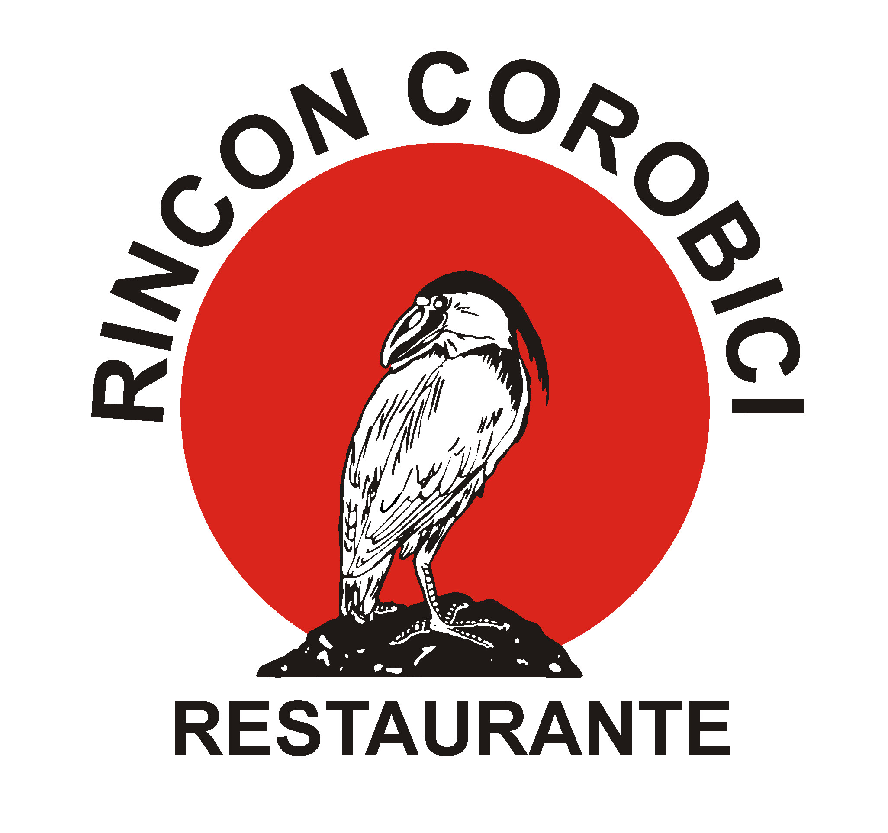
Tel: (506) 2669-6262 / 2669-6006
Fax: (506) 2669-6161
e-mail: reservas@rinconcorobici.com
www.rinconcorobici.com

Cañas, Guanacaste, C.R.

Tours Descriptions

Corobici and Tenorio River Floating, Class I y II

Located right in the hearth of the province of Guanacaste, the Corobici and Tenorio river offers some and moderated waves, this is a wide and fast-flowing class I and II river. This experience is great for all ages, safe enough for children and gentle enough for the elderly to enjoy, just as for nature lovers and bird watchers who will enjoy the lush vegetation of the tropical dry forest. You we’ll have the chance to observe lots of animals: howler and white faced monkeys; coatis, iguanas and otters; you may also sight some of the 300 species of birds that inhabit the nearby Palo Verde National Park: wood stork, king fishers, roseate spoonbill, boat-billed heron, bare-throated tiger heron, white ibis and many, many more, all can be spotted in the threes along the riverbanks of the Corobici and Tenorio river. Think no more, join us and delight your senses with this marvelous experience that nature offers you.

Our journey begins in the gardens of the Corobici River, where our headquarters are located, and the trip last for about 2 hours on the river and includes: paddles, lifejackets, safety kayak if only one raft traveling, bottled water during the tour. Our experienced guides will better let you enjoy of this awesome adventure, pointing for you the tropical flora along the river that will be the perfect background for this unforgettable and unique tour. You will also have the possibility to do some paddle, or if you prefer so, let the guide take you down the river while you relax and enjoy of the emerald forest and exotic fauna.
Season: All year.

Floating down Corobici or the Tenorio River, an unforgettable experience.

Tenorio River, Pozo Azul White water rafting Class III and IV section:

If you are prepared for a huge adventure, you are surely ready for this. The Tenorio River will test your courage with its rapids class III and IV (irregular and medium waves, complex maneuverings in fast rapids in its class III; intense and powerful but yet predictable in the class IV).

Guanacaste features a distinctive dry tropical climate and remains largely undiscovered by foreign visitors. Yet it offers natural treasures—including seven national parks, three wildlife reserves that make out of this province “the place” to enjoy of the wild rapids of the Tenorio. For those already rafters this trip is a must. Its continue challenges await you as you plunge through twists, turns and drops down 8 miles of intense, challenging rapids. All participants must be in a good physical condition.

Don’t forget to bring your swim trunks and comfortable wearing clothes to get wet, rubber sole shoes, a complete change of clothes and towel; sun block, sunglasses with secure head straps and a baseball cap or hat that fits tight.

Our meeting point is the Rincon Corobici Restaurant. The trip most not starts after 9:00 a.m., since this is a one day tour. From here, we’ll hit the road and go to the river, located half hour from the restaurant (paved and dirty road) and where our guide’s team will have the safety equipment ready (lifejackets, helmets and paddles) along with the river safety talk. The trip on the river lasts for about 2 ½ hours and includes a river snack at the end; fresh fruits, cookies, natural beverages and water will be served.
After the snack you will make a 55 minutes drive to get to the Rincon Corobici Restaurant where you will have a delicious hot lunch waiting, also you are able to use the rest rooms and else.

All passengers are provided with the necessary safety equipment, always in perfect conditions, to make this tour a great but safe experience.

The Tenorio River has everything on it, you can find a 12 feet drop (class V), one of its kind. It is important to mention that both this drop and some of the most intense rapids weather can or not be ran. Letting you this way, take only specific challenges.

Due to its strategic location, this is a pure magic trip, unsurpassed beauty, and stunning wildlife scenery that will take your breath away.
Season: All year

Rios Tropicales by RCR, the best of Guanacaste for you

