CANOPY DESCRIPTION

Arenal Thrilling Canopy Adventure, ATHICA is located within the Arenal Conservation Area, and is without a doubt a healthy release of adrenaline and an incredible immersion in nature with a moving panoramic view. Zip lining above the tree canopy will not only offer you a great adventure, it will also offer you the opportunity to observe wildlife in its natural habitat. Your zip line adventure will include a 1 hour optional horseback ride to El Silencio Observation point where you can safely observe the dried lava of previous eruptions of the majestic Arenal Volcano which has formed channels of volcanic rock along the mountainside.
Your tour will begin with a warm welcome and a brief safety speech, after which your equipment will be put on and carefully checked by our bilingual guides, all of which are certified by ICT (Costa Rican Board of Tourism). This certification provides you extra assurance that you will be completely safe at all times since the guides are fully trained in first aid, vertical rescue, and have ample knowledge of the Flora and Fauna of this beautiful country. Enjoy this thrilling aerial adventure of approximately 3 km, starting from a tower 13 meters high and glide your way down 8 cables made with the best galvanized stainless steel, ranging from 80 meters to 750 meters in length. Each of our 12 platforms, which 5 of them are constructed in extraordinary trees, were strategically designed at varying heights to allow our clients to observe the rainforest from different angles and photograph the awe inspiring scenery.

At the platform # 10, Enjoy the amazing Tarzan Swing, where you have to jump to a secure rope and literally throw yourself off a platform, then you start swinging back and forth between the trees, that allows you an incredible view of the mighty Arenal Volcano as well as the rainforest above, below and around you as a healthy rush of adrenaline surges through your bones for an adventure you will never forget.

Hours:
Special Departures established for Canopy + Tarzan Swing + horseback riding at: 8:00 a.m, 10:30 a.m 1:00p.m and we have the last departure time just canopy + tarzan swing at 3:00 p.m.
Duration:
Complete tour duration is 2.5 or 3 hours, depending on group size. If you do not wish to enjoy the horseback portion, please inform at time of reservation. This tour may take less time without the horseback.
Safety:
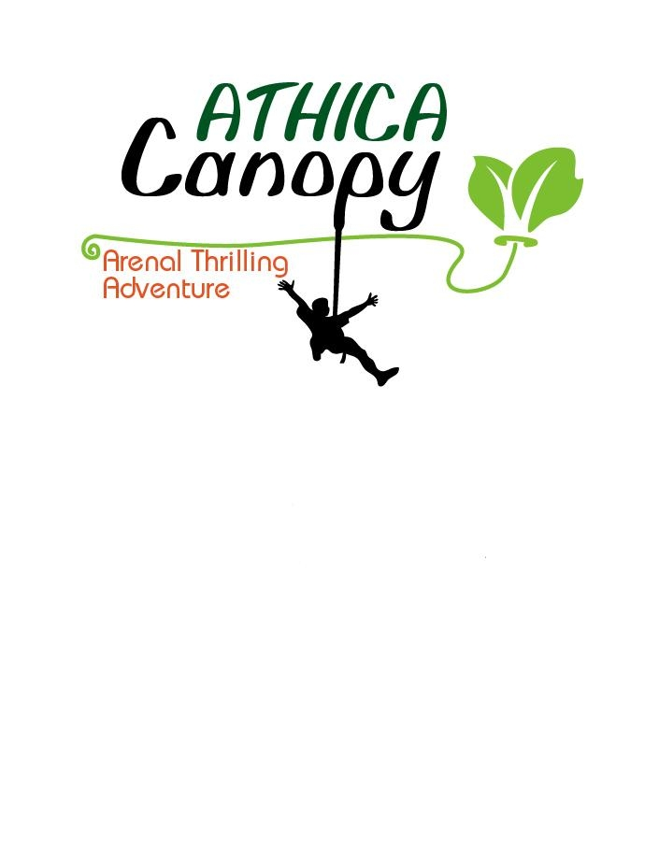
All of our equipment from harnesses and helmets to cables and pulleys meets the highest standards of quality and safety and is certifies by national and international institutions including the Association of Challenge Course Technology ACCT, The Union of International Associated Alpinists UIAA. Each of our platforms and cables have been constructed by field experts and certified by the School of Architects and Engineers of Costa Rica and additionally have all the MINAE and INS permits and policies to guarantee the safety and enjoyment of our guests.
Tour Details:
- Includes: 8 cables of Zip lining, 1 Tarzan Swing, Horseback, Arenal Volcano Observation point, Certified Equipment, Free Hotel pick up and drop off in La Fortuna or El Castillo , Water, Bilingual Guides.
- Note: We recommend long pants for the horse ride, tennis shoes or closed toe shoes, sunscreen and insect repellent. Camera and binoculars are optional.
- We are located 13km west of the Catholic Church, La Fortuna, Across from El Silencio Observation point.

HORSEBACKRIDING DESCRIPTION
For horse-lovers and those who wish to enjoy the most fascinating scenery in the Arenal Conservation Area, our one hour horseback ride is the perfect combination to your canopy adventure.
This tour is apt for beginning and expert riders. Your safety is of vital importance to us. Our professional, experienced, bilingual guides will carefully choose the right horse for you and give you all necessary instructions to teach you to control your horse. All of our horses are calm, manageable, and well trained for this type of activity. Our clients will enjoy speeds apt for the least experienced of the group, or have the opportunity to join a group that better matches their riding level. Inform your guide of your level of experience, and follow all given instructions, in order to assure that you fully enjoy this adventure, that will leave you speechless.
The trails gradually go up through the farmlands, where you will discover the biodiversity that surrounds you including a variety of ferns, bromeliads, woodlands, sugar cane, green pastures and an excellent view of giant trees such as the “Higueron”. Finally, we will reach the Silencio Observation Point, where you will have the opportunity to view the magnificent Arenal Volcano and its dry lava trails from prior eruptions. Be sure to have your camera ready to capture this awe inspiring sight. After which, we will ride back to the stable, taking the same route down.

Our horseback ride can be arranged for any time you’d like, either before or after your canopy zip line adventure. Don’t forget to bring your sunglasses, sunblock, and insect repellent for your added comfort and protection. Our experienced guides would be happy to help you in any way they can to assure you have an unforgettable experience.
Come and share the experience of your life with us!

